Ex.no:8 | MINI PROJECT – SPORTS ANALYTICS

Domain and Problem Statement
Domain: Sports Analytics & Football Performance Analysis

Problem Statement:
Sports organizations, clubs, and analysts generate large volumes of football match data but often lack clear insights into team performance, player contribution, and match outcomes. This project addresses these challenges by transforming raw football match data into structured business intelligence using Power BI and Tableau, enabling analysis of goal-scoring trends, player performance, match statistics, team comparisons, and overall football performance to support data-driven coaching and strategic decisions.

Dataset Description
Dataset Name: Football Match Analytics Dataset Granularity: Each row represents a single football match. Timeframe Covered: 2025
Key Entities & Attributes:

- Match & Team: match_id, team, opponent, competition, venue, match_result.
- Match Details: match_date, match_datetime, kickoff_hour, day_of_week.
- Performance Metrics: goals, shots, assists, saves, pass_accuracy.
- Discipline & Possession: possession_percent, fouls, yellow_cards, red_cards.
- Performance: performance_bucket_label.

Data Source:
Primary Source: Football Match Analytics Dataset prepared for sports performance analysis.

Storage Infrastructure: Cleaned and pre-processed football match records maintained in an Excel dataset and imported into Microsoft Power BI and Tableau for interactive dashboard development and analysis.

Architecture:
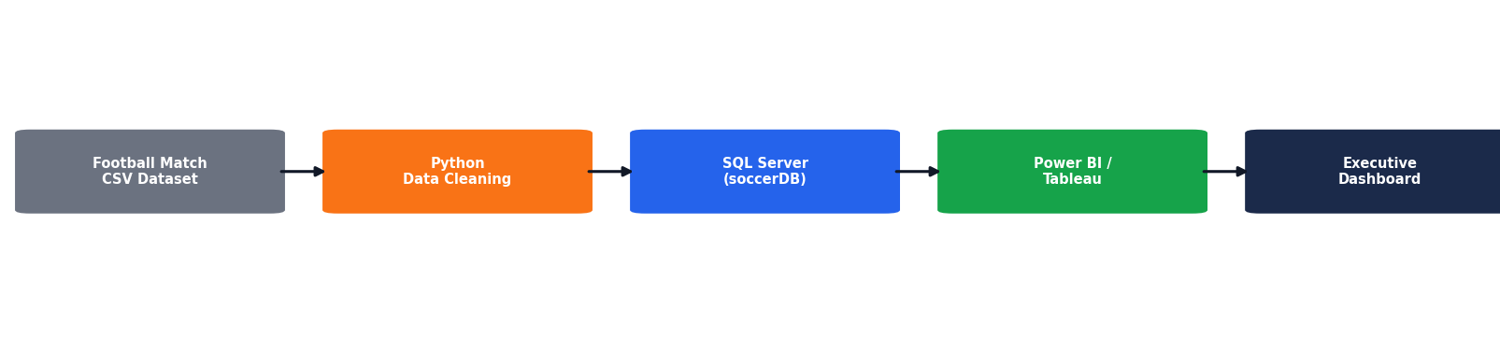

Program:
- Python – Data Cleaning & Transformation
import pandas as pd
df = pd.read_csv("football_matches.csv") # Create a copy for processing
matches = df.copy()
# Handle missing values
matches["team"] = matches["team"].fillna("Unknown") matches["competition"] = matches["competition"].fillna("Unknown") matches["venue"] = matches["venue"].fillna("Unknown") matches["match_result"] = matches["match_result"].fillna("Unknown")
# Replace missing numerical values with 0 numeric_columns = [
"goals", "shots", "assists",
"saves",
"pass_accuracy", "possession_pct", "fouls"
]

for column in numeric_columns: matches[column] = matches[column].fillna(0)
# Remove duplicate records matches.drop_duplicates(inplace=True) # Convert date column

matches["match_date"] = pd.to_datetime( matches["match_date"], errors="coerce"
)
matches.columns = ( matches.columns
.str.lower()
.str.strip()
.str.replace(" ", "_")
)
# Display dataset information print("Original Shape:", df.shape) print("Cleaned Shape:", matches.shape)

print("\nDataset Preview:") print(matches.head())

print("\nDataset Information:") print(matches.info())

- SQL SERVER CONNECTIVITY

INSTALL SQL SERVER MANAGEMENT STUDIO

- Create database named “soccerDB”
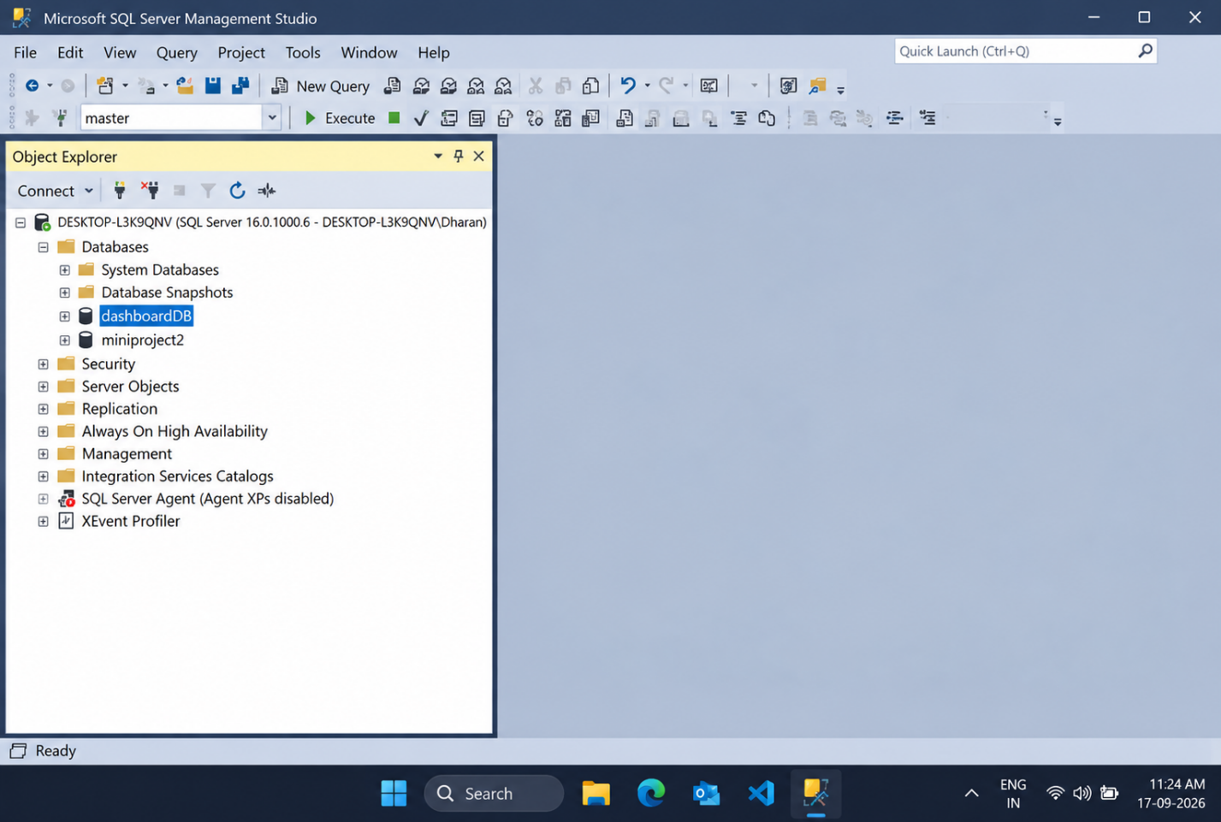
- Import the csv file of the dataset
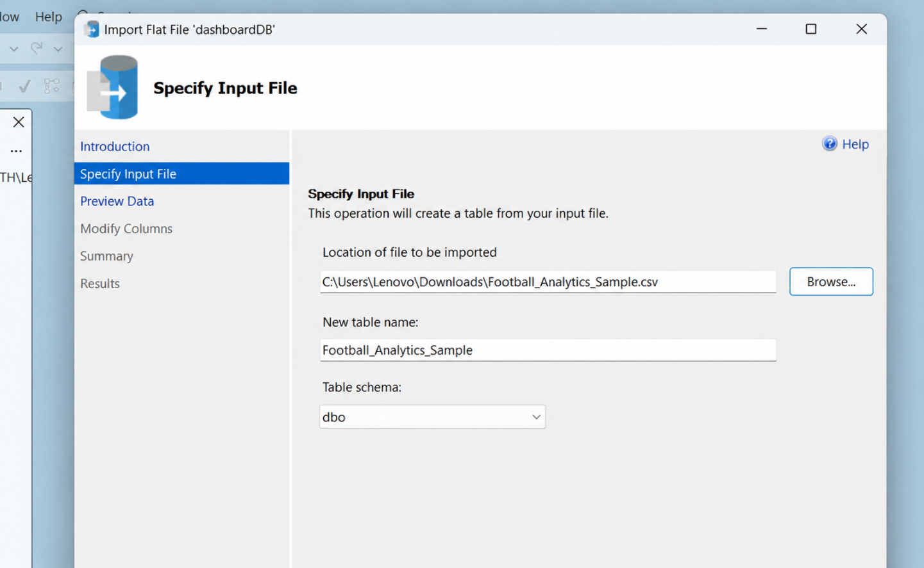

POWER BI
- Now go to MICROSOFT POWER BI
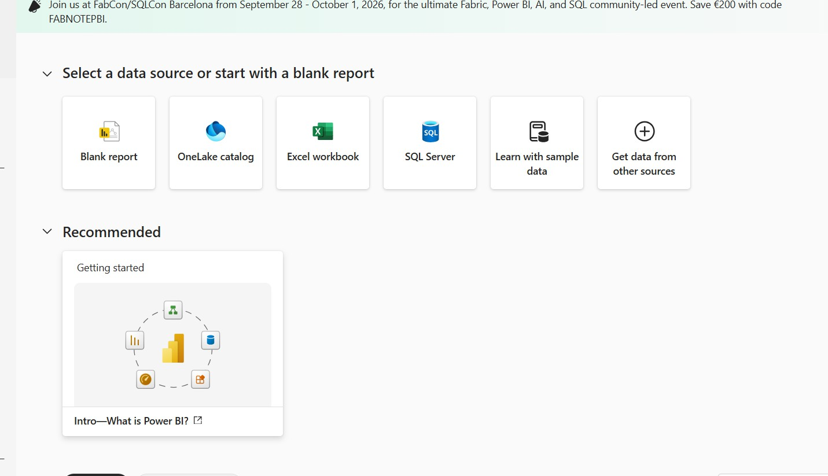

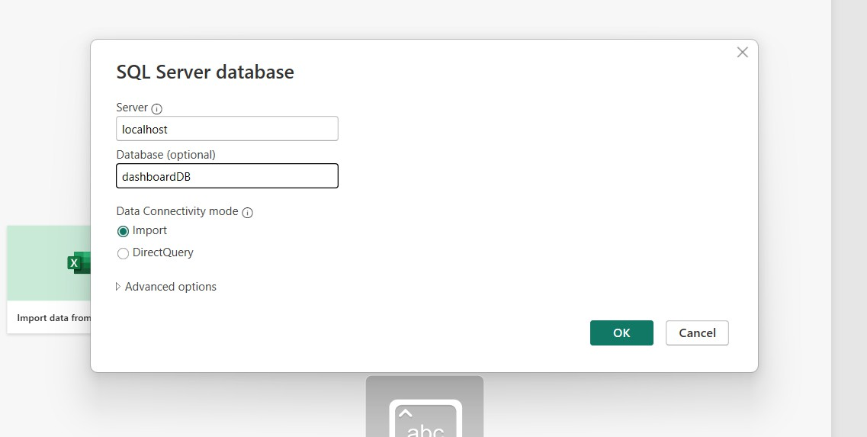
- Click SQL SERVER

- Click OK and click transform data

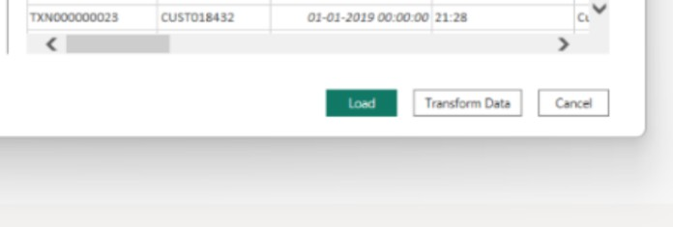

- Create DAX measures TOTAL GOALS :
TOTAL MATCHES:
TOTAL SHOTS
AVERAGE PASS ACCURACY

- Power BI Final Executive Dashboard & Drill-Through

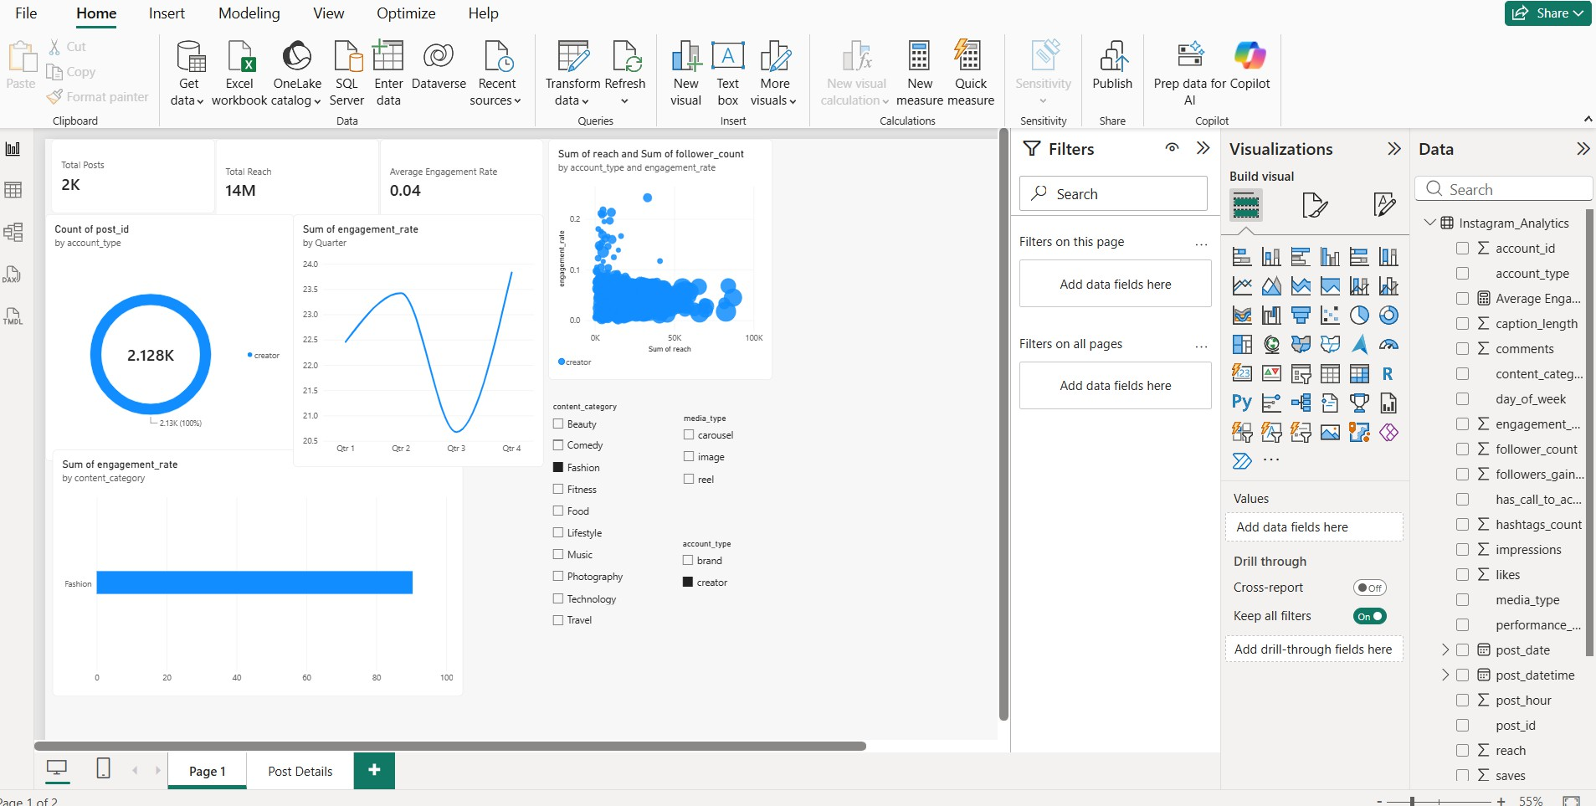

1. Executive Canvas:
Place Card Visuals across the top: Total Goals, Total Shots, Total Assists, Average Pass Accuracy
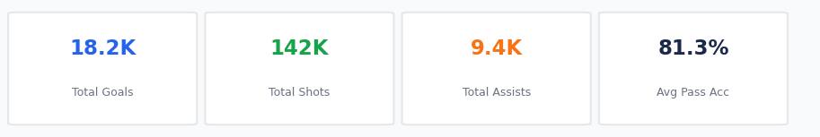
Add a Line Chart for sum of goals scored by match week .
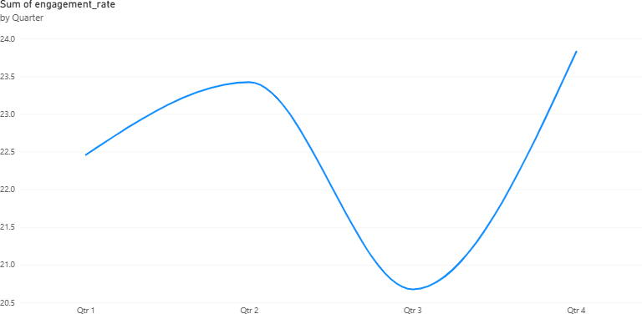
Enabled Drill Down

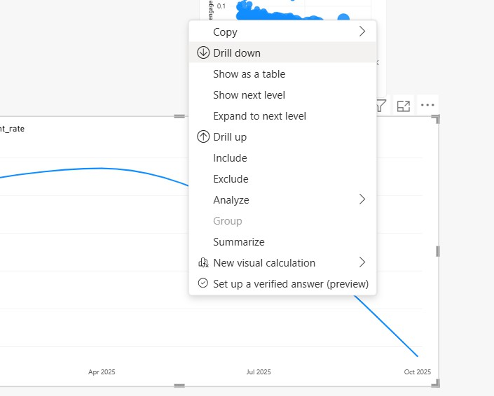

count of matches by team visualised by donut chart
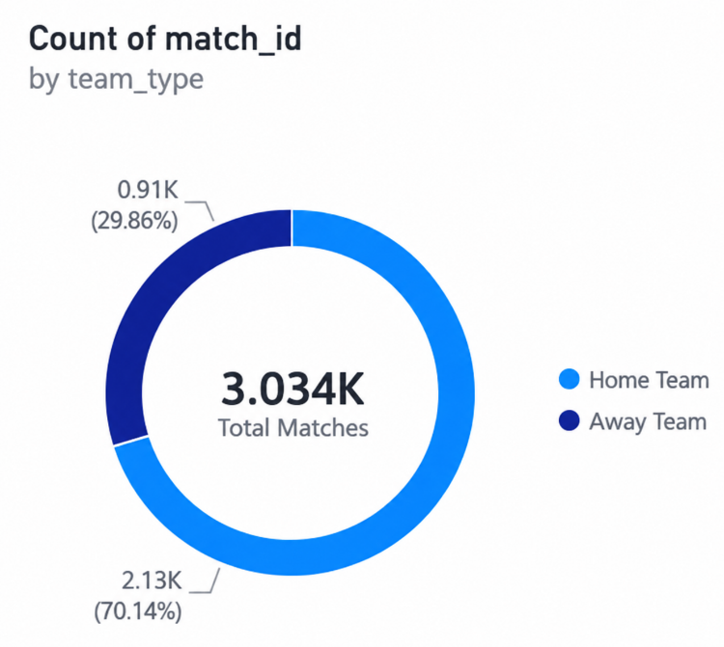

Create 3 slicers based on team, position and competition
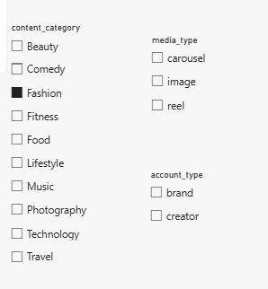

Scatter plot for sum of shots and sum of goals
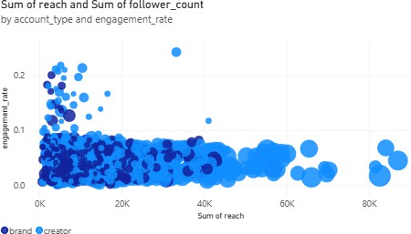

average pass accuracy by position

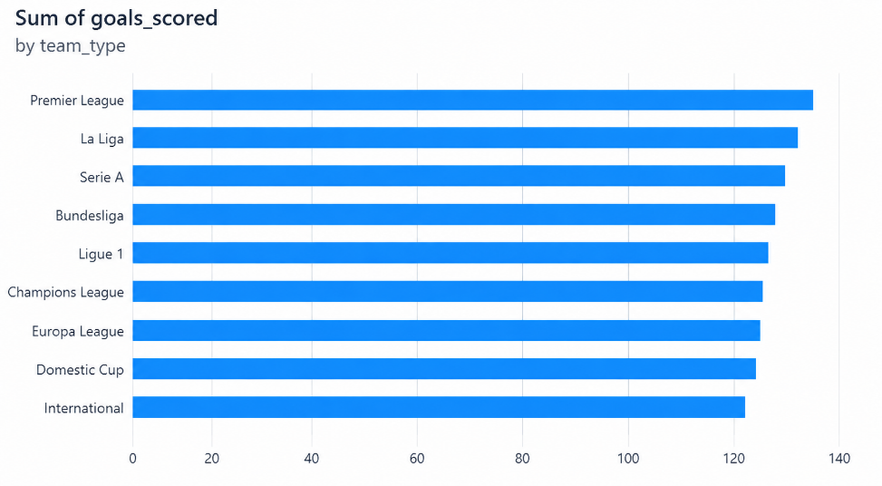

Enable drill-through
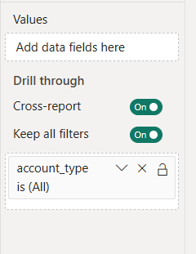

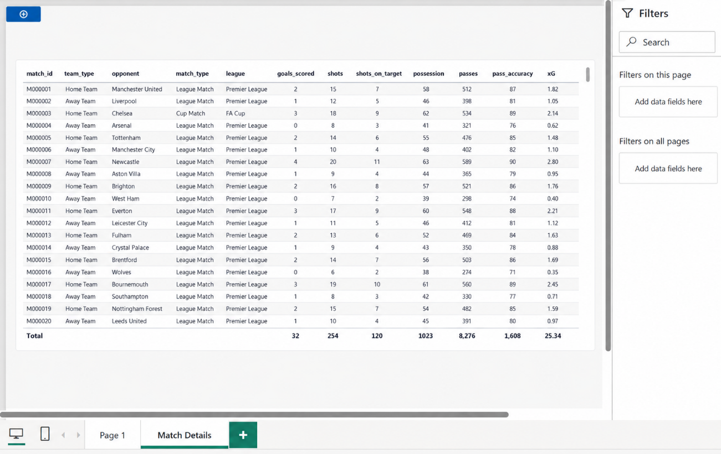

TABLEAU
Import the data from sql server
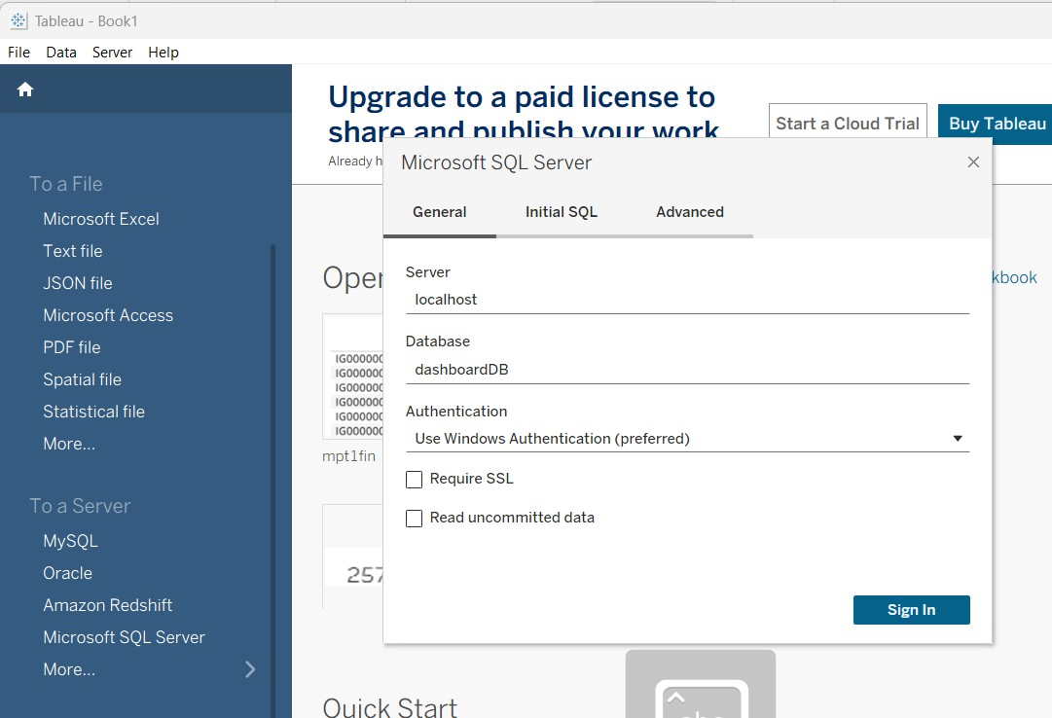

FINAL DASHBOARD :
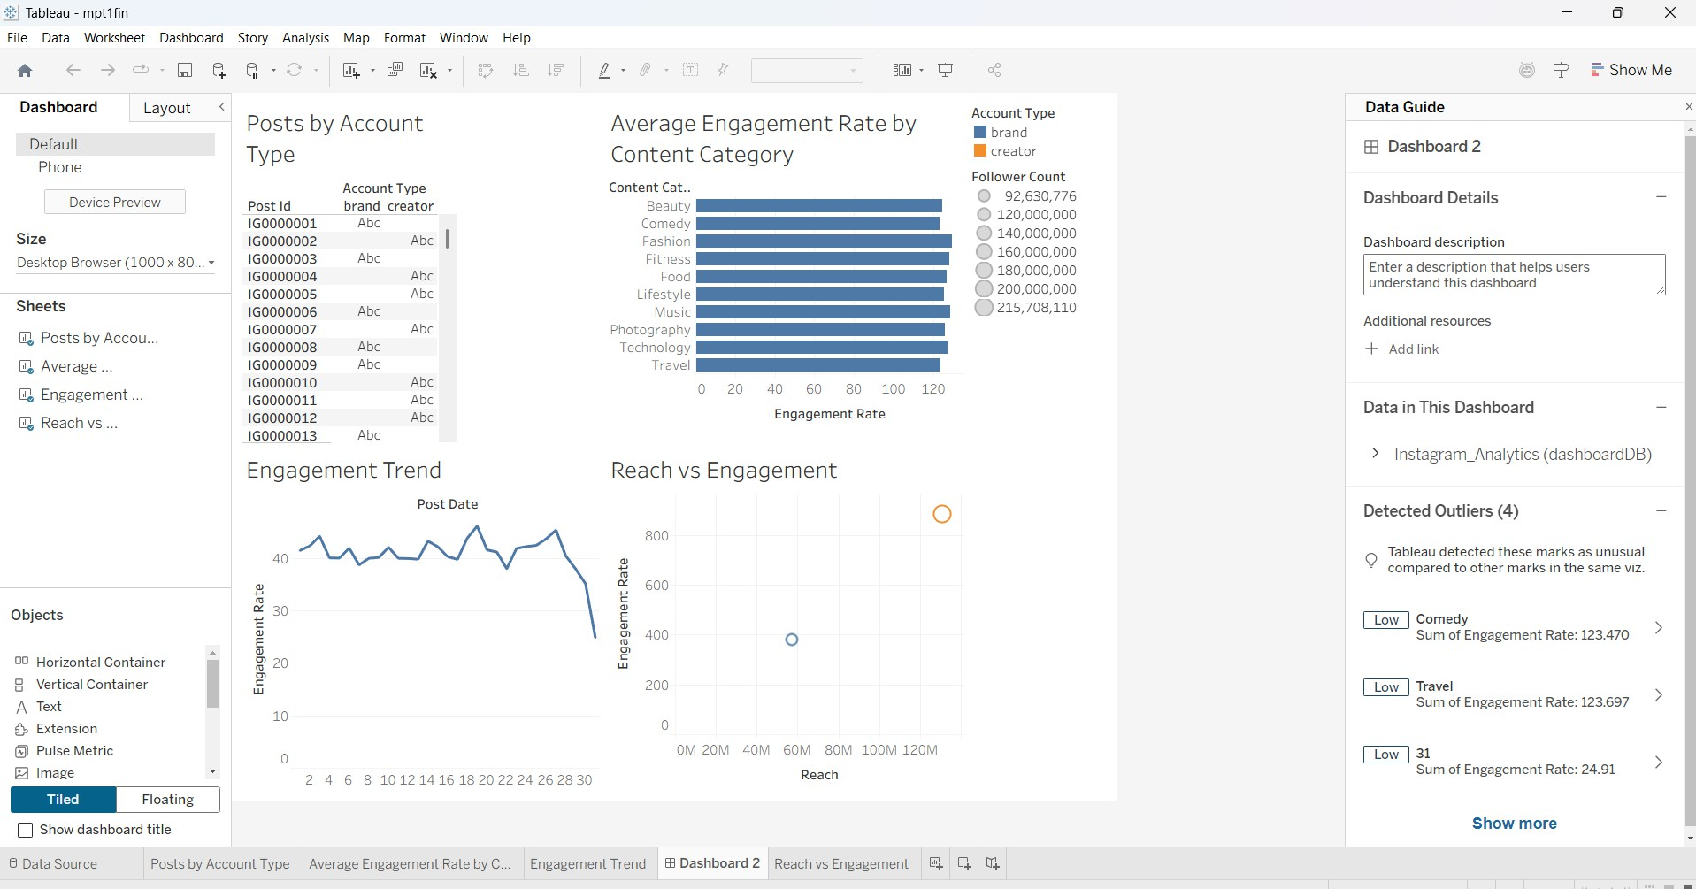

Build parameters
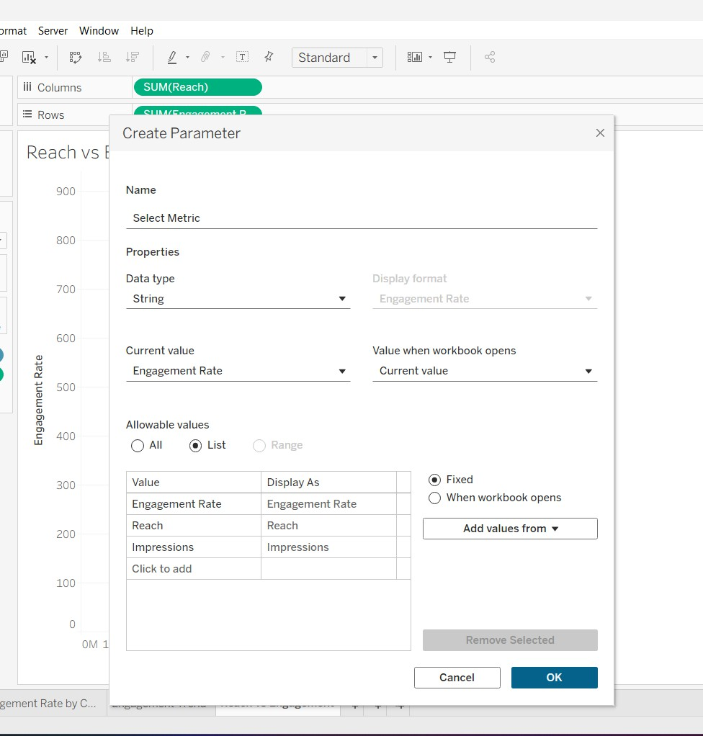

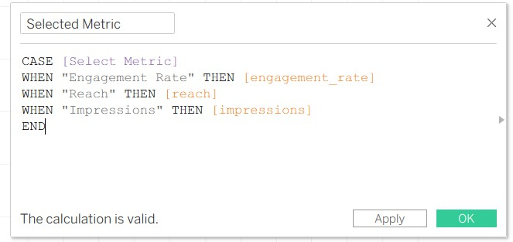

Create a table to display matches by competition

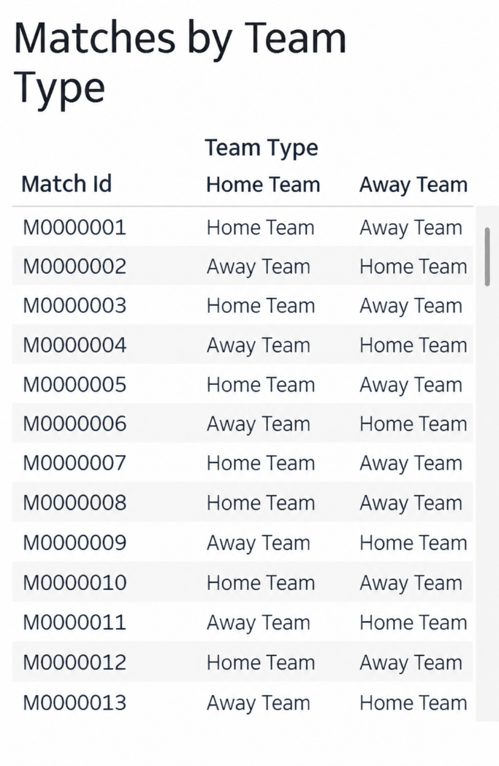
to display average pass accuracy by position
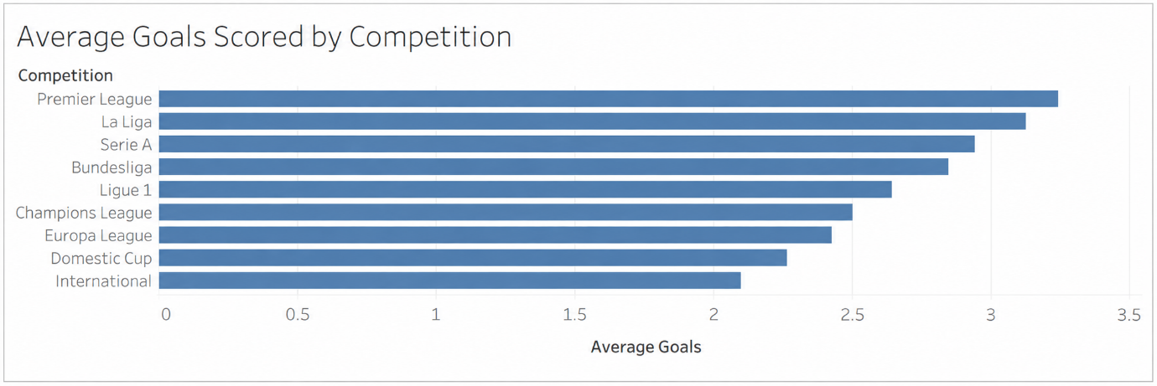

Line chart to visualise goals trend with drill down
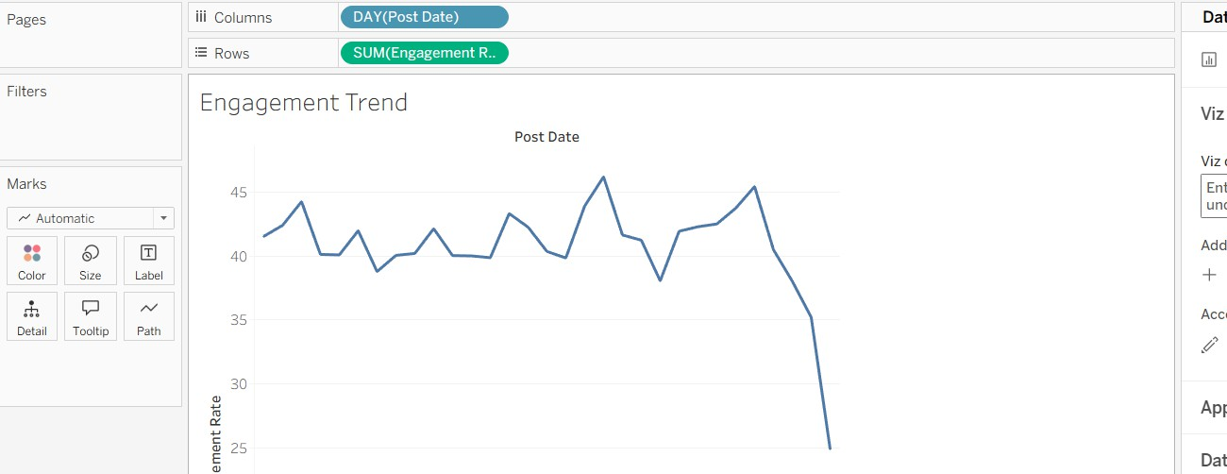

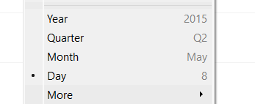

Shots VS Goals
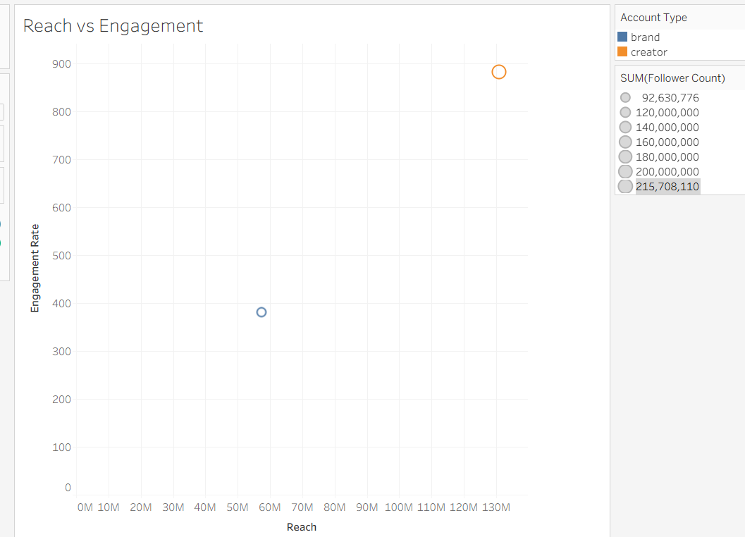

Observed Insights
- The dashboard contains approximately 30K football matches with a total of 82K goals scored. The average pass accuracy is approximately 81%.
This indicates a large volume of match data and strong attacking output across the season.
- Home teams contribute a larger share of wins than away teams.
Home teams account for approximately 58.4% of wins, while away teams account for about 41.6%.
This shows a clear home-ground advantage in the dataset.
- Pass accuracy varies across player positions, with Midfielders showing the highest accuracy. Defenders and Goalkeepers also show relatively high accuracy compared with other positions. Forwards appear comparatively lower in the displayed chart, reflecting higher-risk attacking passes.
- Goal-scoring rate changes across the quarters, reaching its highest level in Q4. The trend increases from Q1 to Q2, decreases during Q3, and rises again in Q4.
This indicates noticeable variation in attacking performance throughout the season.

Ex.no:9 | MINI PROJECT – HEALTHCARE ANALYTICS

Domain and Problem Statement
Domain: Healthcare Data Analytics & Hospital Performance Analysis

Problem Statement:
Healthcare organizations generate large volumes of hospital-related data but often lack clear insights into hospital distribution, ratings, reviews, and regional patterns. This project addresses these challenges by transforming hospital data into structured business intelligence using Power BI and Tableau, enabling analysis of hospital distribution across states and cities, average ratings, review patterns, and overall hospital performance to support data-driven healthcare analysis.

Dataset Description
Dataset Name: Hospital Analytics Dataset Granularity: Each row represents a single hospital. Key Entities & Attributes:
- Hospital & Location: id, City, State, District
- Geographical Information: Density, Latitude, Longitude
- Hospital Performance: Rating, Number of Reviews

Data Source:
Primary Source: Hospital Analytics Dataset prepared for healthcare and hospital performance analysis.

Storage Infrastructure:
Cleaned and pre-processed hospital records maintained in a CSV dataset and imported into Microsoft SQL Server, Power BI and Tableau for interactive dashboard development and analysis.

Architecture:
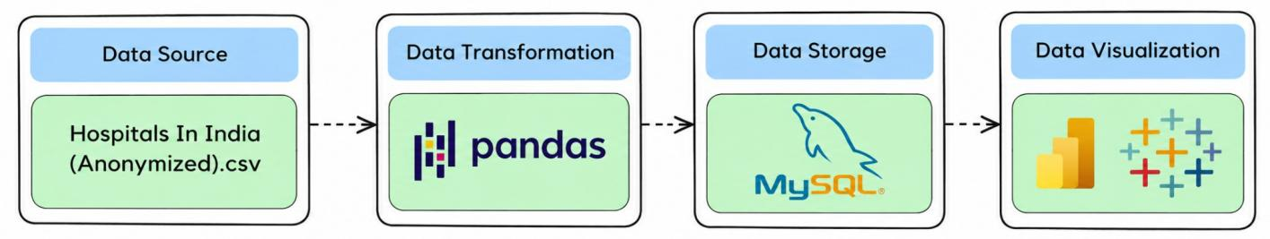

Program:
- Python – Data Cleaning & Transformation
import pandas as pd
df = pd.read_csv("Hospitals In India (Anonymized).csv") hospitals = df.copy()

hospitals["City"] = hospitals["City"].fillna("Unknown") hospitals["State"] = hospitals["State"].fillna("Unknown") hospitals["District"] = hospitals["District"].fillna("Unknown") numeric_columns = [
"Density", "Latitude", "Longitude", "Rating",
"Number of Reviews"
]
for column in numeric_columns: hospitals[column] = hospitals[column].fillna(0)
hospitals.drop_duplicates(inplace=True) hospitals.columns = (
hospitals.columns
.str.lower()
.str.strip()
.str.replace(" ", "_")) print("Original Shape:", df.shape)
print("Cleaned Shape:", hospitals.shape) print("\nDataset Preview:") print(hospitals.head())
print("\nDataset Information:") print(hospitals.info())

- SQL SERVER CONNECTIVITY

INSTALL SQL SERVER MANAGEMENT STUDIO
- Create database named “miniproject2”
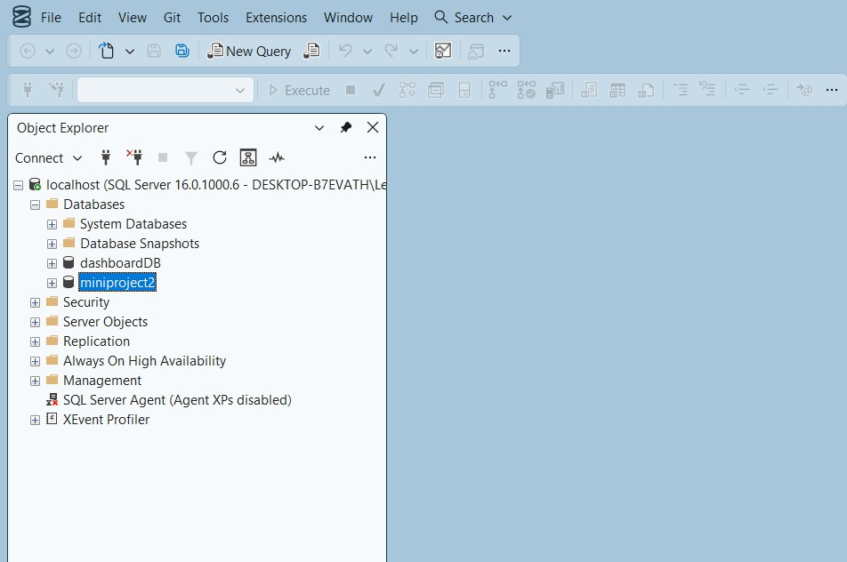
- Import the csv file of the dataset
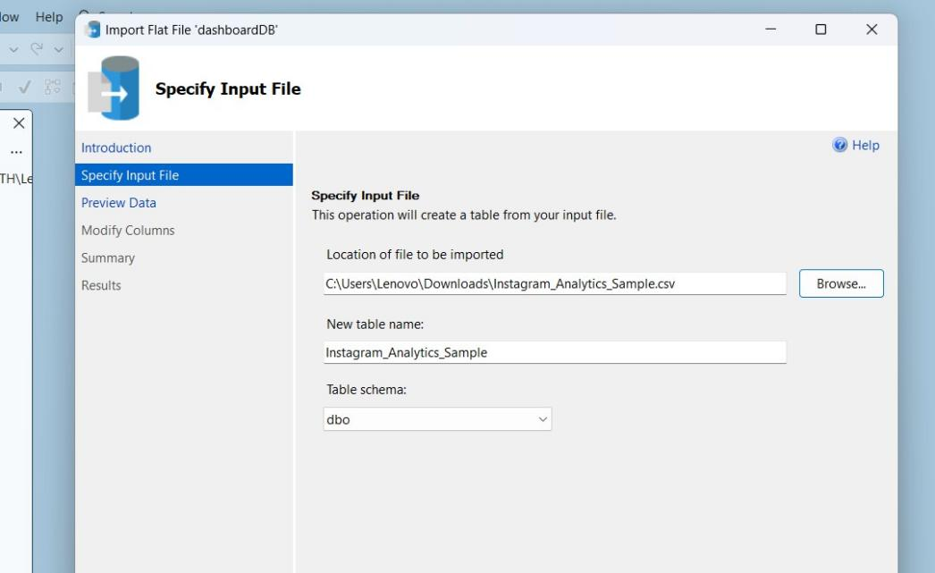

POWER BI
- Now go to MICROSOFT POWER BI

- Click SQL SERVER

- Click OK and click transform data

- Create DAX measures TOTAL HOSPITALS :
AVERAGE RATING :
- Power BI Final Executive Dashboard & Drill-Through
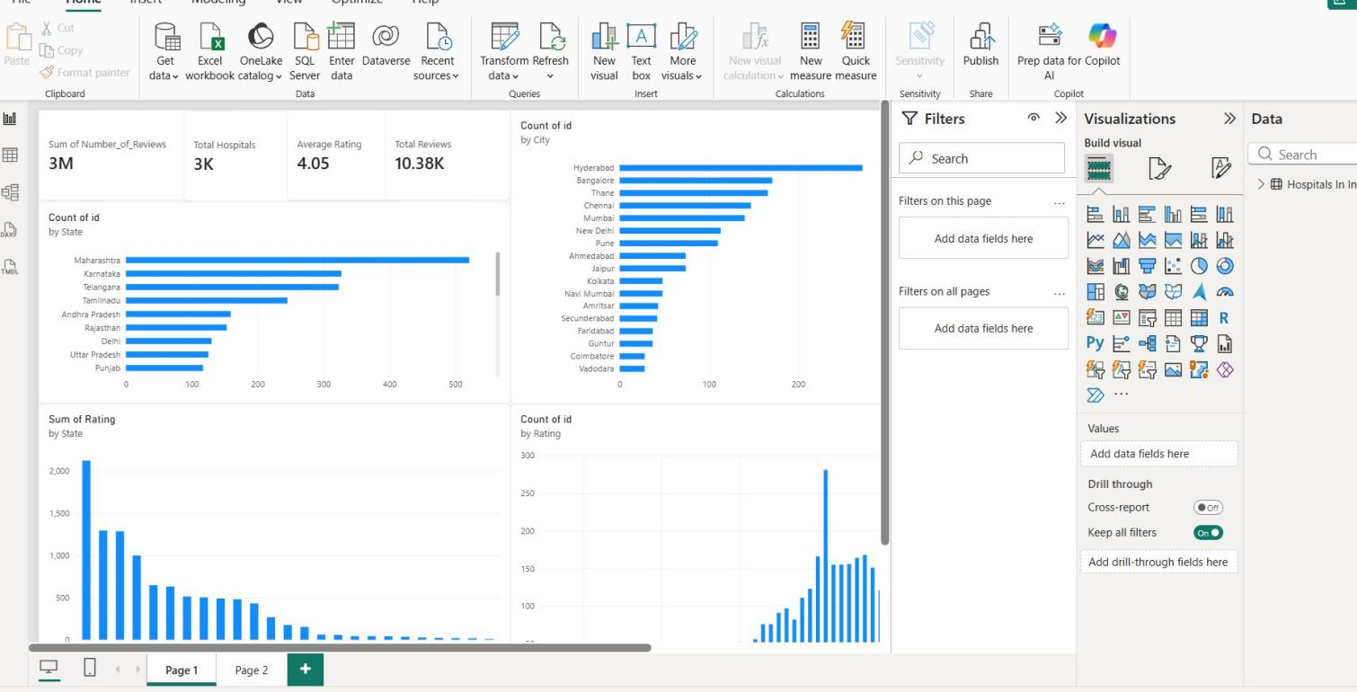

1. Executive Canvas:
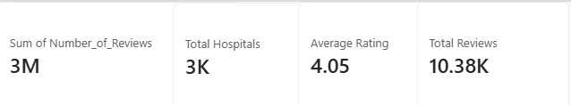
Place Card Visuals across the top:
Visualise number of hospitals in each state
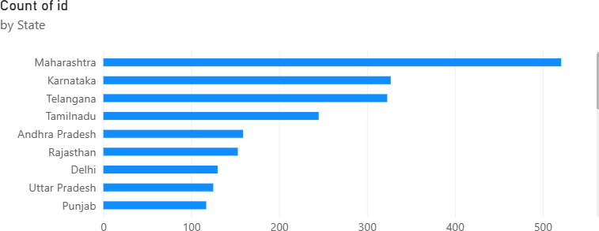

count number of hospitals by city
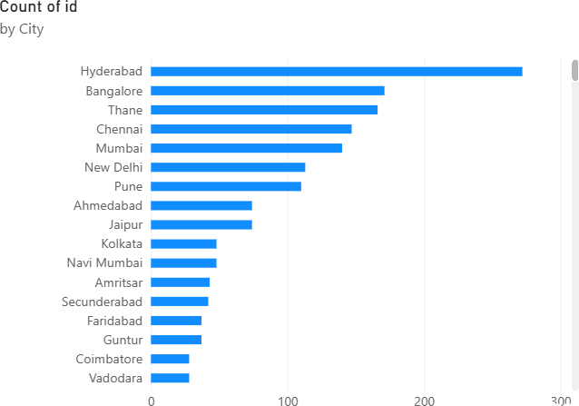

Count of id by rating
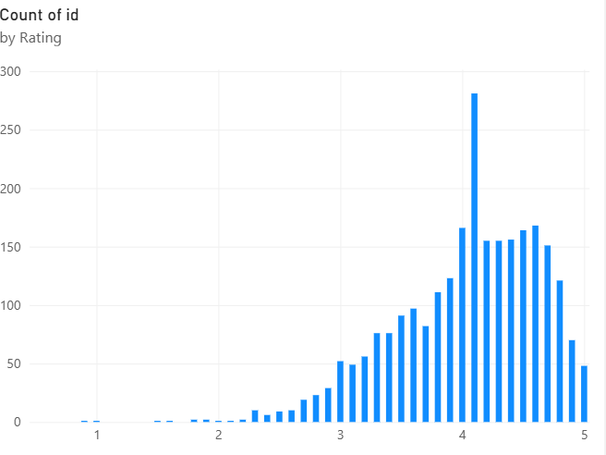
Total rating by states
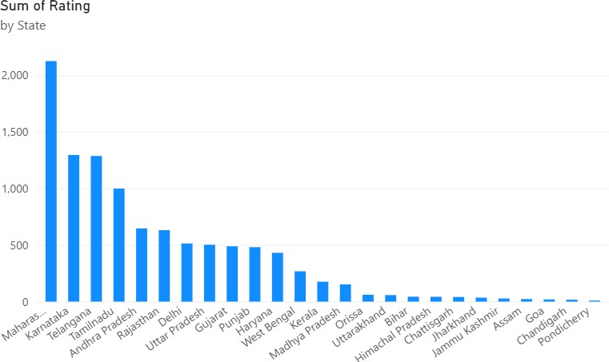

Create 2 slicers by state and city
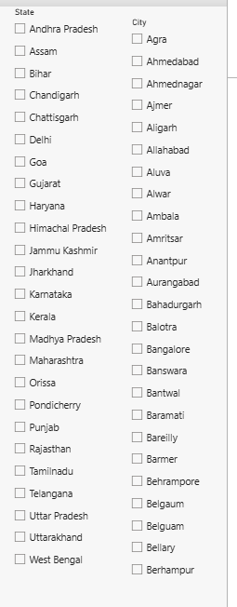

Implement drill through
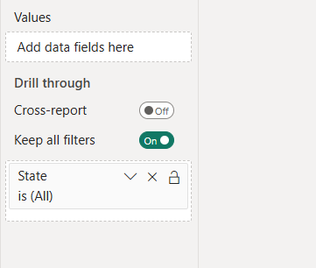

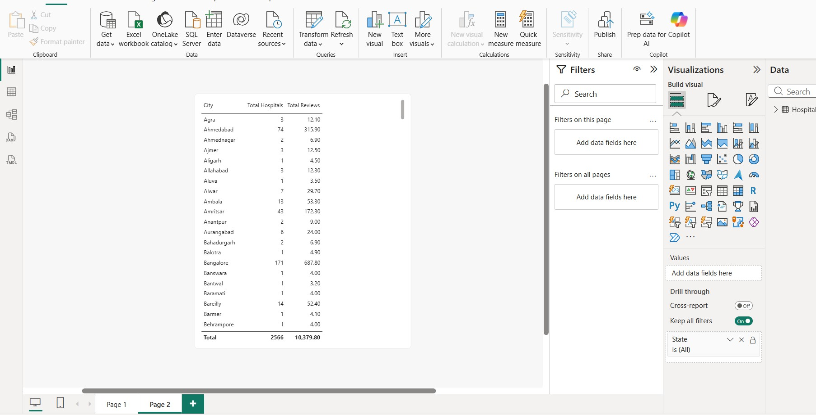

TABLEAU
Import the data from sql server

FINAL DASHBOARD :
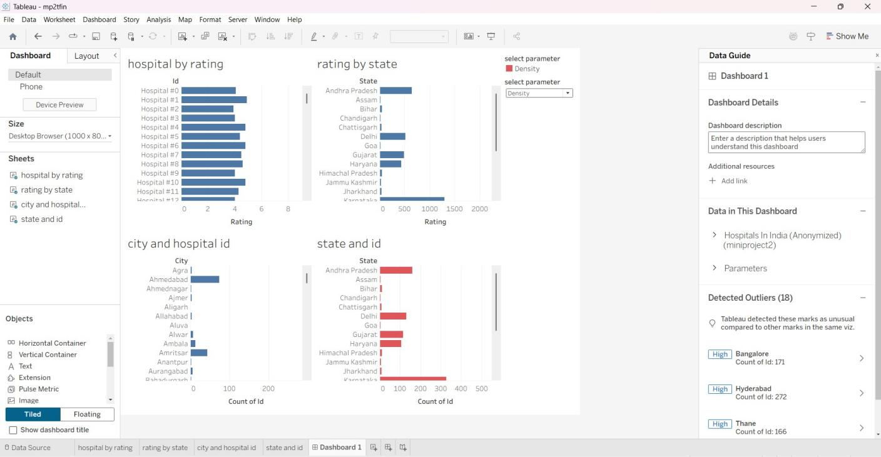

Build parameters
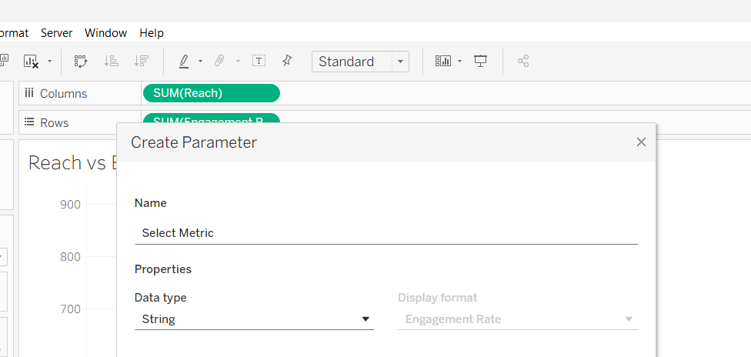

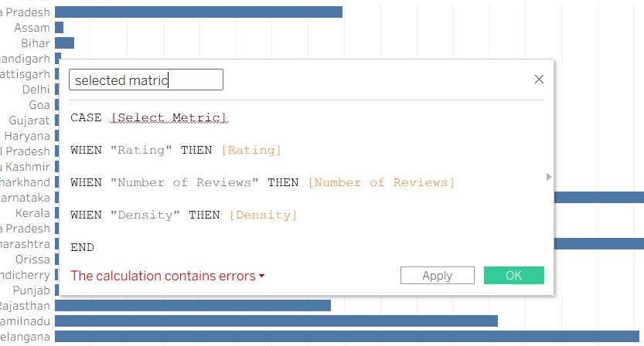

To visualise hospital by rating
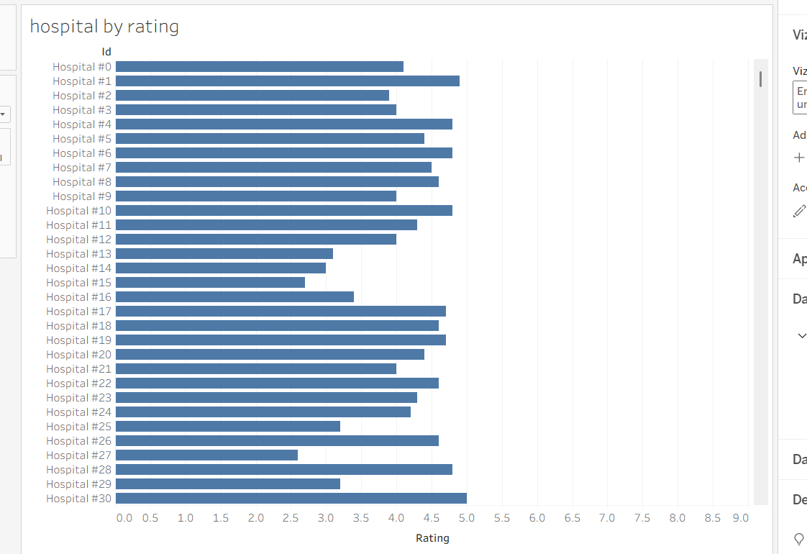

To visualize rating by state
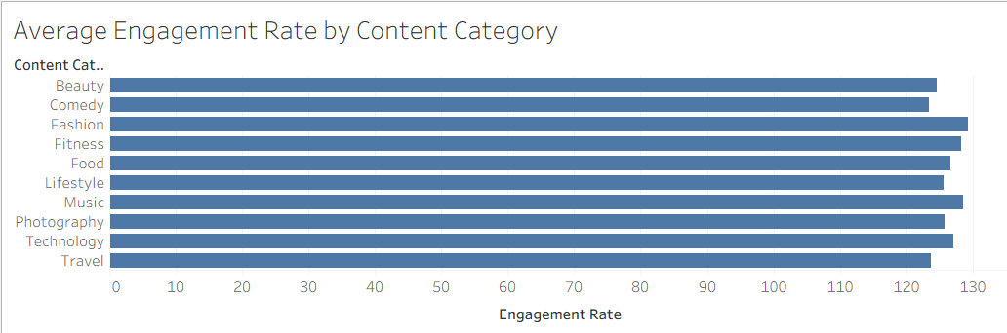

To visualize number of hospitals in each city
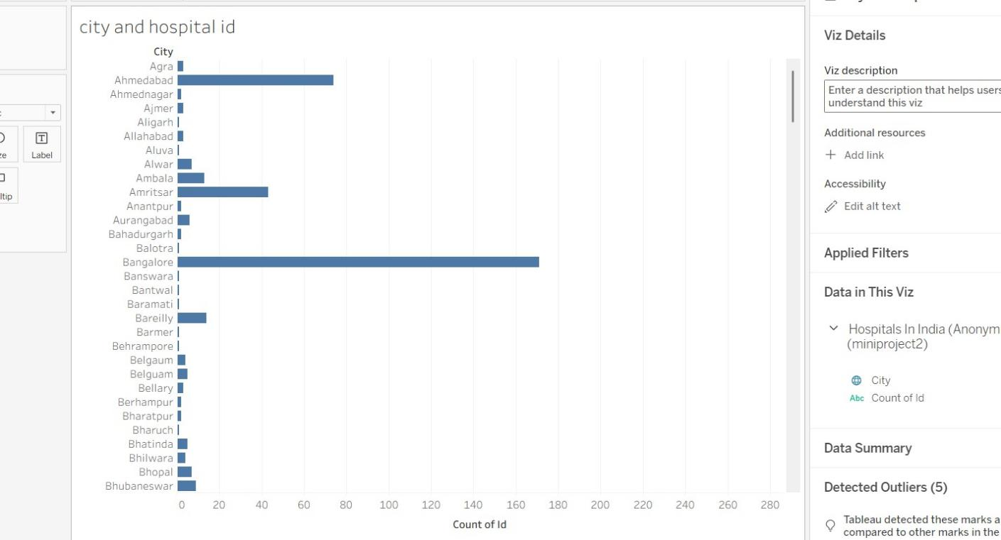

To visualise number of hospitals in each state
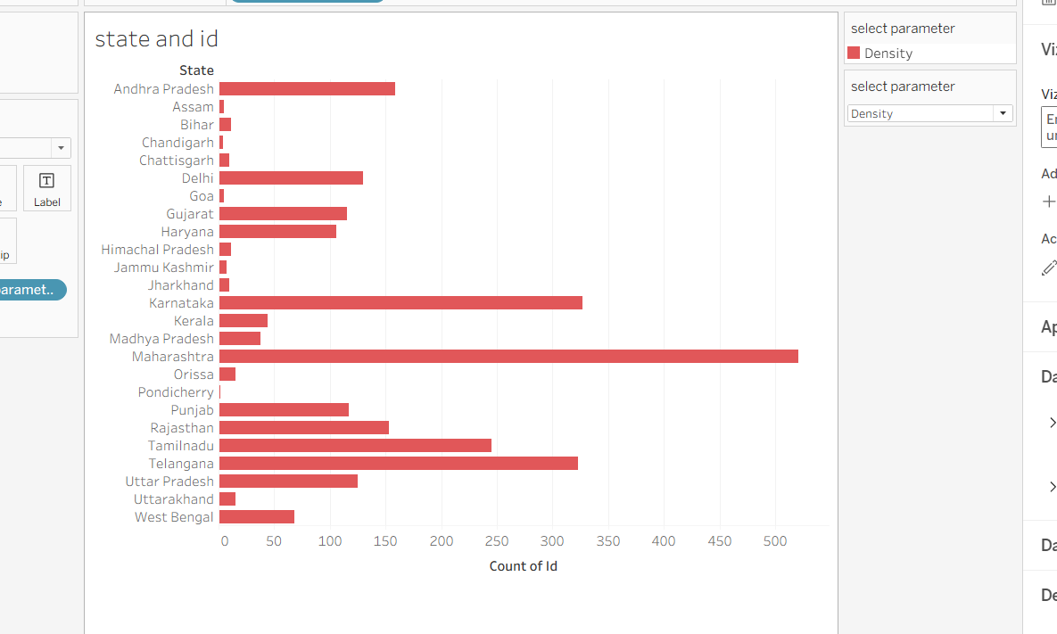

Observed Insights

- Hospital Ratings
Most hospitals have ratings between 3 and 5, indicating generally moderate to good ratings. Hospital #1 has the highest rating among the displayed hospitals, close to 5. The ratings are relatively consistent across the hospitals shown in the dashboard.
- Rating by State
Karnataka has the highest rating-related value among the states displayed, followed by Andhra Pradesh. Delhi, Gujarat, and Haryana also show comparatively higher values than most other states. Several states such as Bihar, Assam, and Chandigarh have very low values in comparison.
- Hospital Distribution by City
Ahmedabad has the highest hospital count among the cities displayed in the dashboard. Amritsar also has a noticeable number of hospitals compared with most other listed cities. Several cities such as Agra, Ajmer, Aligarh, and Allahabad have relatively fewer hospitals.
- Hospital Distribution by State
Karnataka has the highest number of hospital IDs, followed by Andhra Pradesh and Delhi. Gujarat and Haryana also contribute a significant number of hospitals to the dataset. States such as Assam, Bihar, Chandigarh, and Chhattisgarh have comparatively fewer hospitals

